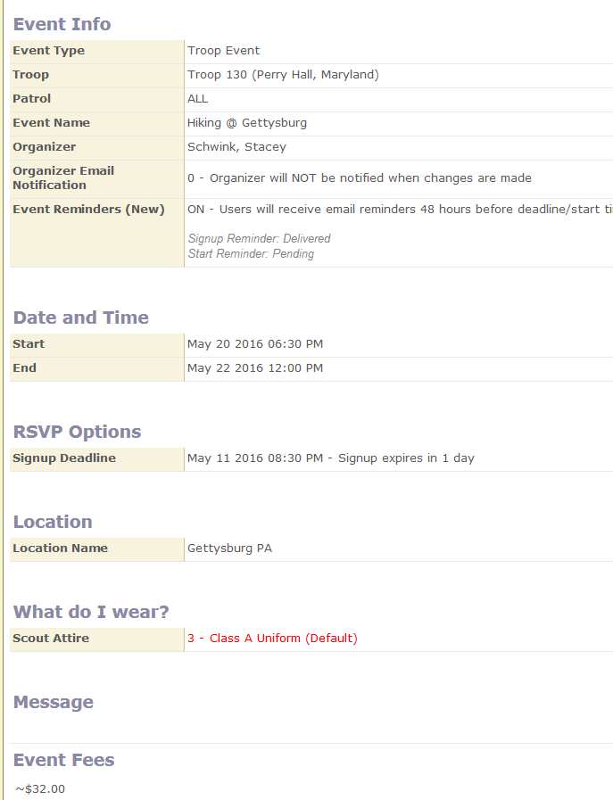Go to Calendar and Open the Event

Find you Name and enter number attending, add a Message if needed, and then Save

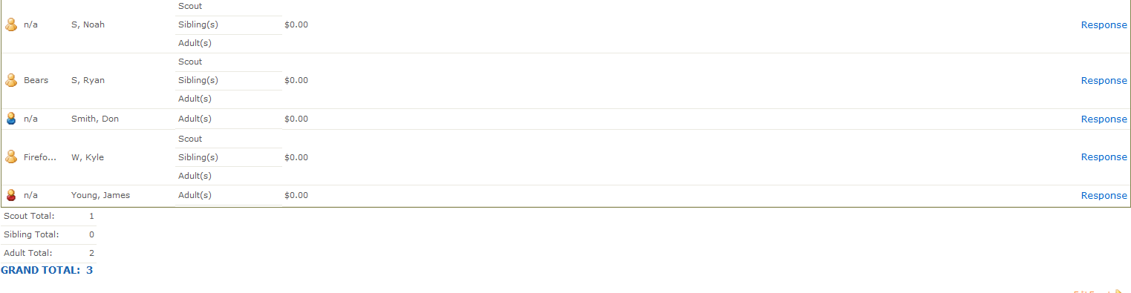
At Bottom will be Total Attending the Event

