March 20, 2019 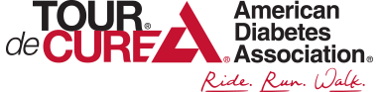

Hi. My name is Ryan Buzard. I recently earned my Arrow of Light rank as a member of Pack 332 and am now a member of Troop 750. I am riding with my family in the 2019 Tour De Cure which benefits the American Diabetes Association. I was diagnosed with having Type 1 Diabetes just over two years ago.
By participating in the Tour De Cure, I hope to raise funds for research and a potential cure. I also hope to spread awareness of the disease. For example, did you know that I can do everything that someone without the disease can do? I just need to take extra care by monitoring and treating my blood sugars throughout the day.
My goal this year is to become a Champion for the event by raising $1,000. One of the ways I am hoping to raise funds is by collecting bottles and cans that I can recycle and turn in for the deposit refund. If you would like to support my efforts, please bring any returnable cans or bottles you have to the next meeting on Tuesday, March 26th.
If you are interested, you can view my progress or even make a donation of any amount via my personal web page at:
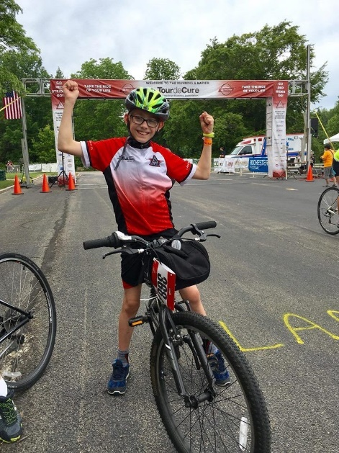
http://main.diabetes.org/goto/rbuzard2019

Thank you very much for your support!

